EXP 20 : ANALYSIS OF CELLULAR FREQUENCY PLANNING AND HANDOVER PERFORMANCE UNDER USER MOBILITY CONDITIONS USING MATLAB
SOFTWARE USED : MATLAB SOFTWARE
CODE :
clc; clear; close all

N=7; R=1000; v=20; dt=1;
freq=[1 2 3 4 5 6 7];
x=0:v:2000;
RSS=zeros(N,length(x));

for i=1:N
d=abs(x-(i-1)*300)+100;
RSS(i,:)=-30-35*log10(d/100);
end

[power,cell]=max(RSS,[],1);
handover=sum(diff(cell)~=0);

subplot(2,1,1)
plot(x,RSS),grid on
title('Cellular Frequency Planning')
xlabel('User Position (m)'),ylabel('Received Power (dBm)')

subplot(2,1,2)
plot(x,cell,'o-'),grid on
title('Handover under User Mobility')
xlabel('User Position (m)'),ylabel('Serving Cell')

fprintf('Total Cells = %d\n',N);
fprintf('User Speed = %d m/s\n',v);
fprintf('Number of Handovers = %d\n',handover);
MODEL GRAPH :
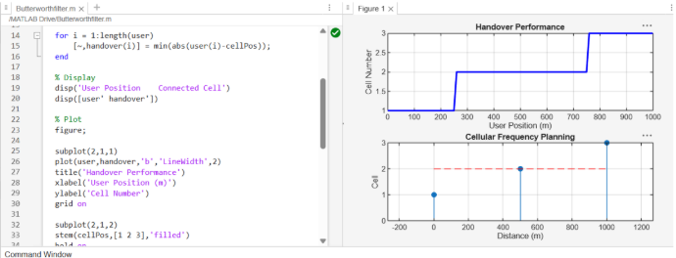
RESULT :

